Introduction

Project Gamezone is a virtual arcade created entirely using Python and making use of the Pygame module, which is a free and open source python programming language library for making multimedia applications, such as games. The project contains two games:

* **Snake It Off**: A new take on the classic game **Snake**, but with two players instead of one. Both players compete to get the apple/food piece to increase their length and try to cut off the path of the other.
* **Stack1e**: A homage to the popular arcade game **Stacker**, developed by LAI Games. In order to win the game, the player must stack 15 rows.

The project is modular, and new games can easily be added to the arcade.

Requirements

The games are operated entirely using a keyboard, although the menu can also be navigated with a mouse.

In order to run the games, Python does not need to be installed on the system, as they have been converted to a Windows executable (.exe) file using the cx_Freeze module.

**Minimum System Requirements**

* Windows 7/8/10
* 200MB RAM
* 30MB HDD/SSD space
* 1GHz CPU

**Recommended System Requirements**

* Windows 7/8/10
* 500MB RAM
* 100MB HDD/SSD space
* 2.5GHz CPU or greater

Menu

**Menu.py**

import sys

sys.path.insert(0, '../../')

import os

import pygame

import pygameMenu

import Stackie

import Snake

color_black = (0, 0, 0)

color_white = (255, 255, 255)

color_background = (17, 165, 240)

color_title = (29, 98, 194)

window_size = (800, 800)

surface = None

def snake():

Snake.main()

def stackie():

Stackie.running = True

Stackie.main()

def main_background():

global surface

surface.fill((20, 20, 20))

def main():

global surface

pygame.init()

surface = pygame.display.set_mode(window_size)

pygame.display.set_caption('Project Gamezone')

pygame.display.set_icon(pygame.image.load("images\gamezone.png"))

main_menu = pygameMenu.Menu(surface,

bgfun=main_background,

color_selected=color_white,

font="fonts/Norwester.otf",

font_color=color_black,

font_size=30,

font_size_title=40,

menu_alpha=100,

menu_color=color_background,

menu_color_title=color_title,

menu_height=int(window_size[1] * 0.7),

menu_width=int(window_size[0] * 0.8),

# User press ESC button

onclose=pygameMenu.events.EXIT,

option_shadow=False,

title='Main menu',

window_height=window_size[1],

window_width=window_size[0]

)

main_menu.set_fps(60)

main_menu.add_option('Snake', snake)

main_menu.add_option('Stack1e', stackie)

main_menu.add_option('Quit', pygameMenu.events.EXIT)

while True:

main_background()

main_menu.mainloop()

pygame.display.flip()

if __name__ == '__main__':

main()

Stack1e

**Stackie.py**

import pygame

import os

from pygame.locals import *

from math import sin

import Menu

boardsize = boardwidth, boardheight = 12, 20

screensize = screenwidth, screenheight = 240, 400

tilewidth = screenwidth/boardwidth

tileheight = screenheight/boardheight

tilesize = tilewidth, tileheight

tilecolor = (232, 130, 6)

tilecolor2 = (6, 232, 134)

black = (0,0,0)

levelspd = (80, 80, 75, 75, 70, 70, 65, 65, 60, 55, 50, 45, 40, 35, 30)

maxwidth = (3, 3, 3, 3, 3, 3, 3, 3, 3, 3, 3, 3, 3, 3, 3)

colorchangey = 10

winlevel = 15

current_speed = 50 #in milliseconds

board = []

lose_tiles = []

current_direction = 1

current_x, current_y, current_width = 0, boardheight - 1, 3

current_level = 0

intro = 0

playing = 1

lose = 2

win = 3

game_state = intro

data_py = os.path.abspath(os.path.dirname(__file__))

data_dir = os.path.normpath(os.path.join(data_py, 'images'))

def filepath(filename):

return os.path.join(data_dir, filename)

def load_image(filename):

return pygame.image.load(os.path.join(data_dir, filename))

bg_images = (load_image("intro.png"), load_image("game.png"), load_image("lose.png"), load_image("win.png"))

bg_images[win].set_colorkey(black)

bg_images[lose].set_colorkey(black)

running = True

pygame.init()

pygame.display.set_caption('Stack1e')

pygame.display.set_icon(pygame.image.load("images\stackie.png"))

def main():

pygame.display.set_caption('Stack1e')

pygame.display.set_icon(pygame.image.load("images\stackie.png"))

global game_state, current_x, current_y, current_speed, running, current_width, current_level

screen = pygame.display.set_mode(screensize)

reset_game()

while(running):

update_movement()

update_board_info()

update_screen(screen)

for event in pygame.event.get():

if event.type == pygame.QUIT:

running = False

elif event.type == KEYDOWN:

if event.key == K_SPACE:

key_hit()

elif event.key == K_ESCAPE:

if game_state == intro:

Menu.main()

running = False

else:

reset_game()

elif event.key == K_LCTRL:

current_x -= 1

if (current_x < 0): current_x = 0

current_width += 1

if (current_width >= boardwidth): current_width = boardwidth - 1

pygame.display.quit()

def reset_game():

global game_state, current_x, current_y, current_speed, running, current_width, current_level, lose_tiles

clear_board()

lose_tiles = []

running = True

game_state = intro

current_x = 0

current_y = boardheight - 1

current_level = 0

current_speed = levelspd[current_level]

current_width = maxwidth[current_level]

def key_hit():

global running, game_state, current_x, current_y, current_width, current_speed, current_level, lose_tiles

if game_state == playing:

if current_y < boardheight - 1:

for x in range(current_x, current_x + current_width):

if board[x][current_y + 1] == 0:

current_width -= 1

board[x][current_y] = 0

lose_tiles.append((x, current_y, pygame.time.get_ticks()))

current_level += 1

check_win_lose()

current_y -= 1

elif game_state == intro:

game_state = playing

elif (game_state == lose) or (game_state == win):

reset_game()

game_state = intro

else:

running = False

def check_win_lose():

global game_state, current_width, current_level, current_speed, running, tilecolor

if current_width == 0:

game_state = lose

elif current_level == winlevel:

current_speed = 100

game_state = win

else:

current_speed = levelspd[current_level]

if current_width > maxwidth[current_level]:

current_width = maxwidth[current_level]

last_time = 0

def update_movement():

global game_state, last_time, current_x, current_y, current_width, current_speed, current_direction

current_time = pygame.time.get_ticks()

if (last_time + current_speed <= current_time):

if game_state == playing:

new_x = current_x + current_direction

if (new_x < 0) or (new_x + current_width > boardwidth):

current_direction = -current_direction

current_x += current_direction

last_time = current_time

def update_screen(screen):

global game_state

if game_state == playing:

draw_background(screen)

draw_board(screen)

elif game_state == intro:

draw_background(screen)

pass

elif (game_state == lose) or (game_state == win):

screen.fill(black)

draw_board(screen)

draw_background(screen)

pygame.display.flip()

def draw_background(screen):

global game_state

screen.blit(bg_images[game_state], (0,0,screenwidth,screenheight), (0,0,screenwidth,screenheight))

def update_board_info():

global game_state

if game_state == playing:

clear_row(current_y)

fill_current_row()

def draw_board(screen):

for x in range(boardwidth):

for y in range(boardheight):

if board[x][y] == 1:

draw_tile(screen, x, y)

draw_lose_tiles(screen)

def draw_tile(screen, x, y):

xoffset = 0

col = tilecolor

if (y < colorchangey):

col = tilecolor2

if game_state == win:

xoffset = sin(pygame.time.get_ticks() * 0.004 + y * 0.5) * (screenwidth / 4)

pygame.draw.rect(screen, col, (x * tilewidth + xoffset, y * tileheight, tilewidth, tileheight))

pygame.draw.rect(screen, black, (x * tilewidth + xoffset, y * tileheight, tilewidth, tileheight), 2)

#Block falling animation

def draw_lose_tiles(screen):

for lt in lose_tiles:

falltime = (pygame.time.get_ticks() - lt[2]) * 0.008 #Time falling

x = lt[0] * tilewidth

y = lt[1] * tileheight + falltime * falltime

col = tilecolor

if (lt[1] < colorchangey):

col = tilecolor2

if (y > screenheight):

lose_tiles.remove(lt)

else:

pygame.draw.rect(screen, col, (x+2, y+2, tilewidth-3, tileheight-3))

def clear_board():

global board

board = []

for x in range(boardwidth):

board.append([])

for y in range (boardheight):

board[x].append(0)

def clear_row(y):

for x in range(boardwidth):

board[x][y] = 0

def fill_current_row():

global current_x, current_y, current_width

for x in range(current_x, current_x + current_width):

board[x][current_y] = 1

if __name__ == '__main__':

main()

Snake It Off

**Game.py**

from Scene import *

from Entity import *

import random

from pygame import gfxdraw

class mainGame(Scene):

def __init__(self, director):

Scene.__init__(self, director)

self.plyronewins = False

self.plyrtwowins = False

self.plyrdraw = False

self.plyronewins_txt = director.font.render("Player One Wins", True, (255, 255, 255))

self.plyrtwowins_txt = director.font.render("Player Two Wins", True, (255, 255, 255))

self.plyrdraw_txt = director.font.render("Draw", True, (255, 255, 255))

self.screen_rect = director.screen.get_rect()

self.plyr = pygame.font.Font("fonts\AD.ttf", 20 * director.scale)

self.txt = self.plyr.render("esc", True, (255, 255, 255))

self.a = director.scale

self.w, self.h = pygame.display.get_surface().get_size()

self.dx1 = 10 * director.scale

self.dy1 = 0

self.dx2 = -10 * director.scale

self.dy2 = 0

#Snake 1

self.head_1 = Entity(21 * director.scale, 1 * director.scale, 9 * director.scale, 9 * director.scale, (11, 27, 176))

self.tail_1 = []

#Snake 2

self.head_2 = Entity(371 * director.scale, 1 * director.scale, 9 * director.scale, 9 * director.scale, (12, 120, 6))

self.tail_2 = []

self.apple = Entity(191 * director.scale, 191 * director.scale, 9 * director.scale, 9 * director.scale, (199, 10, 10))

#Starting condition

pygame.mixer.music.load("music\shake.ogg")

pygame.mixer.music.play(-1)

for i in range(1, 3):

self.tail_1.append(Entity(self.head_1.x - 10 * i * director.scale, self.head_1.y * director.scale, 9 * director.scale, 9 * director.scale, self.director.p1color))

for i in range(1, 3):

self.tail_2.append(Entity(self.head_2.x + 10 * i * director.scale, self.head_2.y * director.scale, 9 * director.scale, 9 * director.scale, self.director.p2color))

def on_event(self, event):

#Snake 1 movement

if event.type == pygame.KEYDOWN and event.key == pygame.K_w and self.dy1 == 0:

self.dy1 = -10 * self.director.scale

self.dx1 = 0

if event.type == pygame.KEYDOWN and event.key == pygame.K_s and self.dy1 == 0:

self.dy1 = 10 * self.director.scale

self.dx1 = 0

if event.type == pygame.KEYDOWN and event.key == pygame.K_a and self.dx1 == 0:

self.dx1 = -10 * self.director.scale

self.dy1 = 0

if event.type == pygame.KEYDOWN and event.key == pygame.K_d and self.dx1 == 0:

self.dx1 = 10 * self.director.scale

self.dy1 = 0

#Snake 2 movement

if event.type == pygame.KEYDOWN and event.key == pygame.K_UP and self.dy2 == 0:

self.dy2 = -10 * self.director.scale

self.dx2 = 0

if event.type == pygame.KEYDOWN and event.key == pygame.K_DOWN and self.dy2 == 0:

self.dy2 = 10 * self.director.scale

self.dx2 = 0

if event.type == pygame.KEYDOWN and event.key == pygame.K_LEFT and self.dx2 == 0:

self.dx2 = -10 * self.director.scale

self.dy2 = 0

if event.type == pygame.KEYDOWN and event.key == pygame.K_RIGHT and self.dx2 == 0:

self.dx2 = 10 * self.director.scale

self.dy2 = 0

#Reset game

if event.type == pygame.KEYDOWN and event.key == pygame.K_r:

pygame.mixer.music.stop()

self.director.change_scene(mainGame(self.director))

pygame.mixer.music.load("music\shake.ogg")

pygame.mixer.music.play(-1)

#Exit game

if event.type == pygame.KEYDOWN and (event.key == pygame.K_ESCAPE):

pygame.mixer.music.stop()

self.director.quit()

def on_update(self):

self.director.fps = 15

if not self.plyronewins and not self.plyrtwowins and not self.plyrdraw:

self.did_eat()

#Movement: Snake 1

for i in range(len(self.tail_1) - 1, 0, -1):

self.tail_1[i].x = self.tail_1[i - 1].x

self.tail_1[i].y = self.tail_1[i - 1].y

self.tail_1[0].x, self.tail_1[0].y = (self.head_1.x, self.head_1.y)

self.head_1.x += self.dx1

self.head_1.y += self.dy1

if self.head_1.x < 0:

self.head_1.x = self.w - (9 * self.a)

if self.head_1.x > self.w:

self.head_1.x = self.a

if self.head_1.y < 0:

self.head_1.y = self.h - (9 * self.a)

if self.head_1.y > self.h:

self.head_1.y = self.a

#Endgame check

self.is_collide()

if self.plyrdraw or self.plyronewins or self.plyrtwowins:

return

#Movement: Snake 2

for i in range(len(self.tail_2) - 1, 0, -1):

self.tail_2[i].x = self.tail_2[i - 1].x

self.tail_2[i].y = self.tail_2[i - 1].y

self.tail_2[0].x, self.tail_2[0].y = (self.head_2.x, self.head_2.y)

self.head_2.x += self.dx2

self.head_2.y += self.dy2

if self.head_2.x < 0:

self.head_2.x = self.w - (9 * self.a)

if self.head_2.x > self.w:

self.head_2.x = self.a

if self.head_2.y < 0:

self.head_2.y = self.h - (9 * self.a)

if self.head_2.y > self.h:

self.head_2.y = self.a

#Endgame check

self.is_collide()

if self.plyrdraw or self.plyronewins or self.plyrtwowins:

return

def on_draw(self, screen):

#Wipe screen

self.director.screen.fill((0, 0, 0))

self.draw_grid(screen)

self.apple.draw(screen)

self.head_1.draw(screen)

self.head_2.draw(screen)

self.print_tails(screen)

#Player 1 wins

if self.plyronewins:

screen.blit(self.plyronewins_txt, self.plyronewins_txt.get_rect(center=self.screen_rect.center))

self.gameEnd(screen)

#Player 2 wins

if self.plyrtwowins:

screen.blit(self.plyrtwowins_txt, self.plyronewins_txt.get_rect(center=self.screen_rect.center))

self.gameEnd(screen)

#Draw

if self.plyrdraw:

screen.blit(self.plyrdraw_txt, self.plyrdraw_txt.get_rect(center=self.screen_rect.center))

self.gameEnd(screen)

def print_tails(self, screen):

for i in range(len(self.tail_1)):

pygame.draw.rect(screen, self.tail_1[i].color, self.tail_1[i].rect())

for i in range(len(self.tail_2)):

pygame.draw.rect(screen, self.tail_2[i].color, self.tail_2[i].rect())

def draw_grid(self, screen):

for i in range(40):

pygame.draw.line(screen, (56, 56, 56), (i * 10 * self.director.scale, 0), (i * 10 * self.director.scale, self.h))

for i in range(40):

pygame.draw.line(screen, (56, 56, 56), (0, i * 10 * self.director.scale), (self.w, i * 10 * self.director.scale))

def did_eat(self):

spaceEmpty = True

currX = self.apple.x

currY = self.apple.y

if self.head_1.x == self.apple.x and self.head_1.y == self.apple.y:

prevX, prevY = currX, currY

currX = myround(random.randint(0, self.w / 10 - 10 * self.director.scale), 10 * self.director.scale) * 10 + 1 * self.director.scale

while prevX == currX:

currX = myround(random.randint(0, self.w / 10 - 10 * self.director.scale), 10 * self.director.scale) * 10 + 1 * self.director.scale

currY = myround(random.randint(0, self.h / 10 - 10 * self.director.scale), 10 * self.director.scale) * 10 + 1 * self.director.scale

while prevY == currY:

currY = myround(random.randint(0, self.h / 10 - 10 * self.director.scale), 10 * self.director.scale) * 10 + 1 * self.director.scale

for i in self.tail_1:

if currX == i.x and currY == i.y:

spaceEmpty = False

while not spaceEmpty and prevX != currX and prevY != currY:

currX = myround(random.randint(0, self.w / 10 - 10 * self.director.scale), 10 * self.director.scale) * 10 + 1 * self.director.scale

currY = myround(random.randint(0, self.h / 10 - 10 * self.director.scale), 10 * self.director.scale) * 10 + 1 * self.director.scale

for j in self.tail_1:

if currX == j.x and currY == j.y:

spaceEmpty = False

break

spaceEmpty = True

self.tail_1.append(Entity(self.tail_1[len(self.tail_1) - 1].x * self.director.scale, self.tail_1[len(self.tail_1) - 1 * self.director.scale].y, 9 * self.director.scale, 9 * self.director.scale, self.director.p1color))

if self.head_2.x == self.apple.x and self.head_2.y == self.apple.y:

prevX, prevY = currX, currY

currX = myround(random.randint(0, self.w / 10 - 10 * self.director.scale), 10 * self.director.scale) * 10 + 1 * self.director.scale

while prevX == currX:

currX = myround(random.randint(0, self.w / 10 - 10 * self.director.scale), 10 * self.director.scale) * 10 + 1 * self.director.scale

currY = myround(random.randint(0, self.h / 10 - 10 * self.director.scale), 10 * self.director.scale) * 10 + 1 * self.director.scale

while prevY == currY:

currY = myround(random.randint(0, self.h / 10 - 10 * self.director.scale), 10 * self.director.scale) * 10 + 1 * self.director.scale

for i in self.tail_2:

if currX == i.x and currY == i.y:

spaceEmpty = False

while not spaceEmpty and prevX != currX and prevY != currY:

currX = myround(random.randint(0, self.w / 10 - 10 * self.director.scale), 10 * self.director.scale) * 10 + 1 * self.director.scale

currY = myround(random.randint(0, self.h / 10 - 10 * self.director.scale), 10 * self.director.scale) * 10 + 1 * self.director.scale

for j in self.tail_2:

if currX == j.x and currY == j.y:

spaceEmpty = False

break

spaceEmpty = True

self.tail_2.append(Entity(self.tail_2[len(self.tail_2) - 1].x * self.director.scale, self.tail_2[len(self.tail_2) - 1 * self.director.scale].y, 9 * self.director.scale, 9 * self.director.scale, self.director.p2color))

#Place new apple

self.apple.x = currX

self.apple.y = currY

def is_collide(self): #Head-On Collision

if self.head_1.x == self.head_2.x and self.head_1.y == self.head_2.y:

self.plyrdraw = True

pygame.mixer.music.stop()

return

for i in self.tail_1:

if self.head_2.x == i.x and self.head_2.y == i.y:

self.plyronewins = True

pygame.mixer.music.stop()

return

if self.head_1.x == i.x and self.head_1.y == i.y:

self.plyrtwowins = True

pygame.mixer.music.stop()

return

for i in self.tail_2:

if self.head_1.x == i.x and self.head_1.y == i.y:

self.plyrtwowins = True

pygame.mixer.music.stop()

return

if self.head_2.x == i.x and self.head_2.y == i.y:

self.plyronewins = True

pygame.mixer.music.stop()

return

def gameEnd(self, screen):

self.txt = self.plyr.render("esc", True, (255, 255, 255))

screen.blit(self.txt, (25 * self.director.scale, 1 * self.director.scale))

gfxdraw.filled_trigon(screen, 5 * self.director.scale, 19 * self.director.scale, 20 * self.director.scale, 26 * self.director.scale, 20 * self.director.scale, 12 * self.director.scale, (232, 107, 35))

gfxdraw.aatrigon(screen, 5 * self.director.scale, 19 * self.director.scale, 20 * self.director.scale, 26 * self.director.scale, 20 * self.director.scale, 12 * self.director.scale, (232, 107, 35))

**Director.py**

import pygame

class Director:

def __init__(self):

self.screen = pygame.display.set_mode((800, 800))

self.scale = int(pygame.display.get_surface().get_width() / 400)

pygame.display.set_caption("Snake It Off")

pygame.display.set_icon(pygame.image.load("images\snake.png"))

self.font = pygame.font.Font("fonts\AD.ttf", 30 * self.scale)

self.scene = None

self.fps = 15

self.quit_flag = False

self.p1color = (16, 99, 232)

self.p2color = (25, 232, 14)

self.index_one = 0

self.index_two = 1

self.clock = pygame.time.Clock()

def loop(self):

while not self.quit_flag:

time = self.clock.tick(self.fps)

for event in pygame.event.get():

if event.type == pygame.QUIT:

self.quit()

if event.type == pygame.KEYDOWN:

if event.key == pygame.K_ESCAPE:

self.quit()

self.scene.on_event(event)

self.scene.on_update()

self.scene.on_draw(self.screen)

pygame.display.flip()

def change_scene(self, scene):

self.scene = scene

def quit(self):

pygame.QUIT

self.quit_flag = True

**Entity.py**

import pygame

from pygame import Rect

class Entity:

def __init__(self, x, y, width, height, color):

self.x = x

self.y = y

self.width = width

self.height = height

self.color = color

def rect(self):

return Rect(self.x, self.y, self.width, self.height)

def draw(self, screen):

pygame.draw.rect(screen, self.color, self.rect())

def myround(x, base=5):

return int(base * round(float(x)/base))

**Scene.py**

from pygame import *

class Scene:

def __init__(self, director):

self.director = director

def on_update(self):

raise NotImplementedError("on_update abstract method must be defined in subclass")

def on_event(self, event):

raise NotImplementedError("on_event abstract method must be defined in subclass")

def on_draw(self, screen):

raise NotImplementedError("on_Draw abstract method must be defined in subclass")

**Snake.py**

from Director import *

from Game import *

def main():

dire = Director()

twop = mainGame(dire)

dire.change_scene(twop)

dire.loop()

pygame.init()

if __name__ == '__main__':

main()

Game Screens

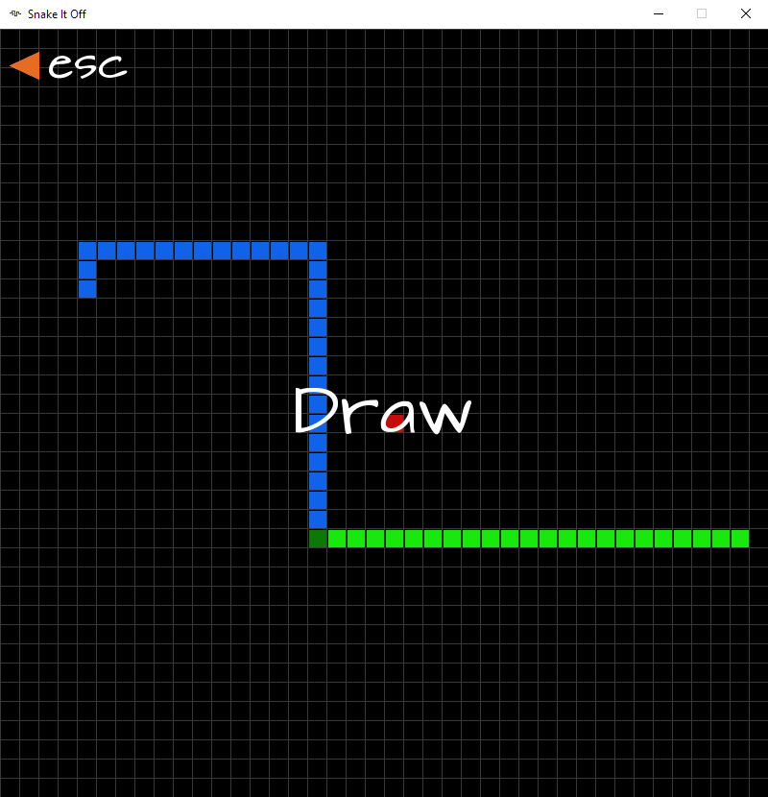**Menu Screen Snake Draw**

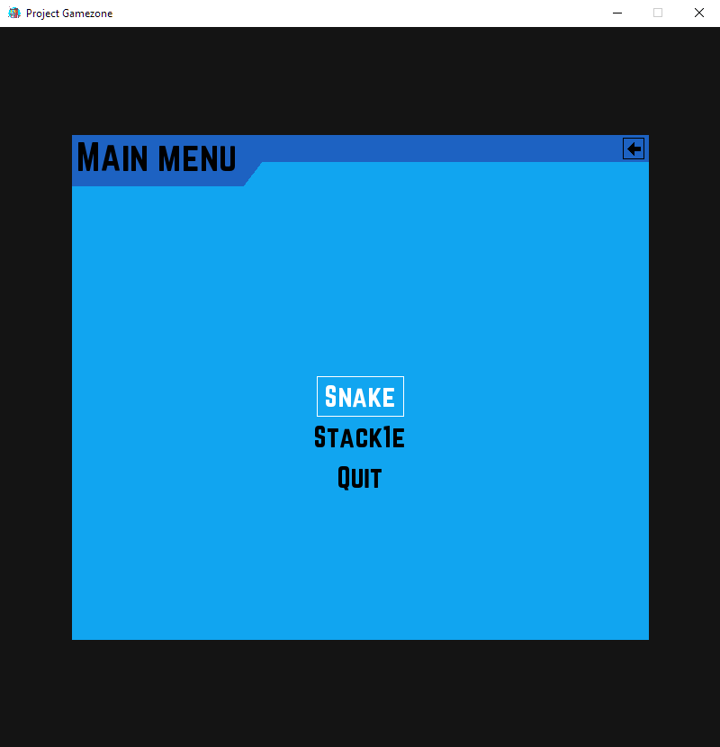

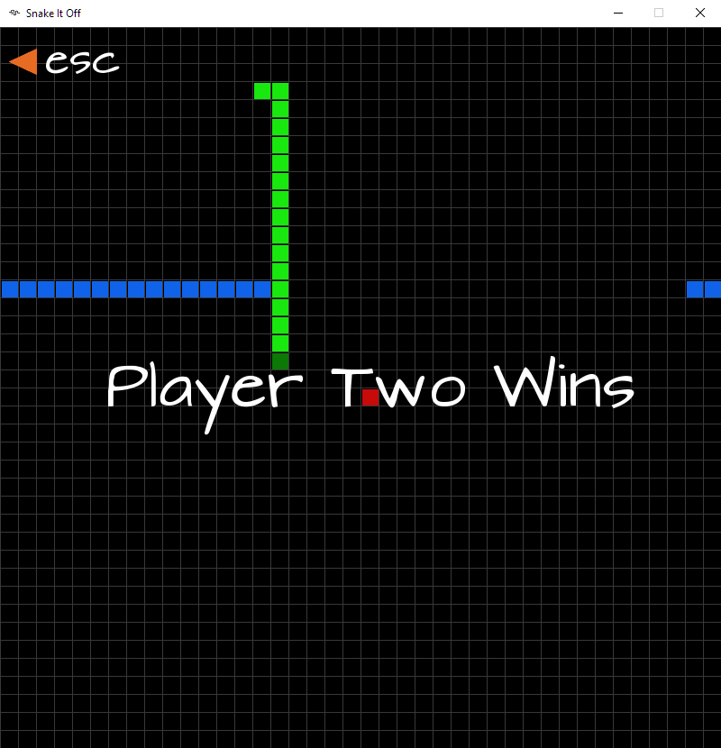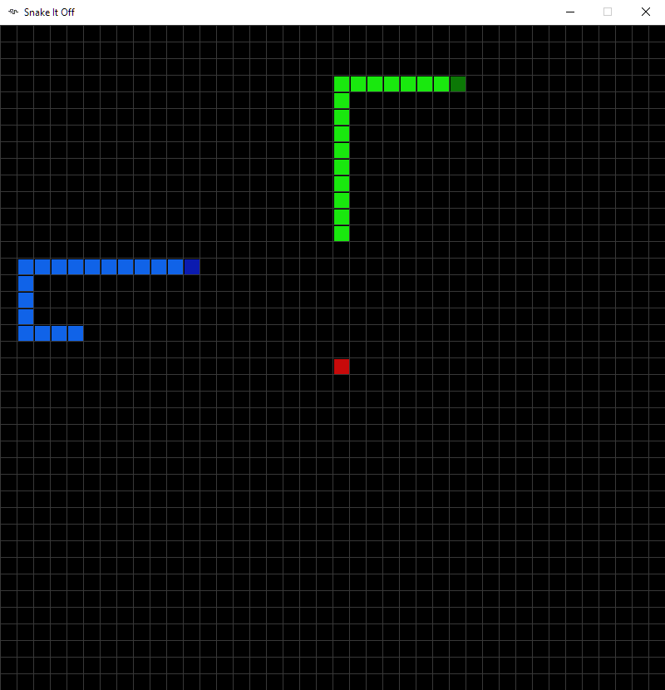**Snake Gameplay Snake Win**

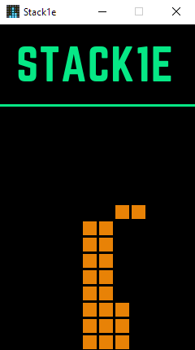**Stack1e Title Screen Stack1e Gameplay**

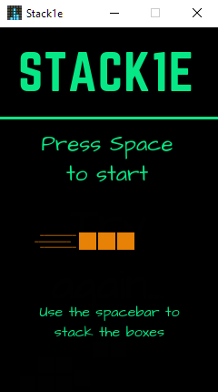

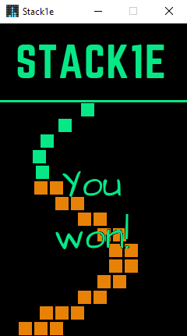**Stack1e Lose Stack1e Win**

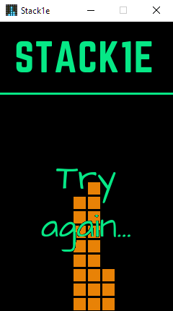

Conclusion

The games were designed in Python using the Atom IDE, owing to its direct integration with GitHub.

The project is online at <https://github.com/arcanemagic/csproject/tree/master/2020>.

Future Plans

* More arcade games can be added.
* Project Gamezone can be converted into a mobile application for Android and iOS.
* Snake It Off and other future multiplayer games can be played over the network.

Bibliography

* Pygame Docs (<https://www.pygame.org/docs/>)
* cx_Freeze Docs (<https://cx-freeze.readthedocs.io/en/latest/overview.html>)
* Pygame-Menu Module (<https://github.com/ppizarror/pygame-menu>)
* Stack Overflow (<https://stackoverflow.com/>)
* Reddit r/pygame (<https://reddit.com/r/pygame>)
* Reddit r/learnpython (https://www.reddit.com/r/learnpython)